Proof of concept in MQTT and KAFKA:

1.What is MQTT (Message Queue Telemetry Transport)

->MQTT is an OASIS standard messaging protocol for the Internet of Things (IoT). It is designed as an extremely lightweight publish/subscribe messaging transport that is ideal for connecting remote devices with a small code footprint and minimal network bandwidth.

2.Use Cases of MQTT

-> 1. Automotive 4. Smart Home



2. Logistics 5. Consumer Products

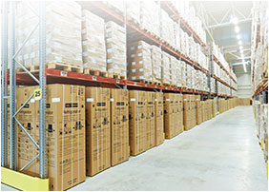

3. Manufacturing 6. Transport

Necessary items:

1. MQTT Publisher- A publisher which takes a topis name from the user or predefined. It publish to a broker to a certain topic.
2. MQTT Subscriber- A subscriber which gets message from the broker from the specified topic.

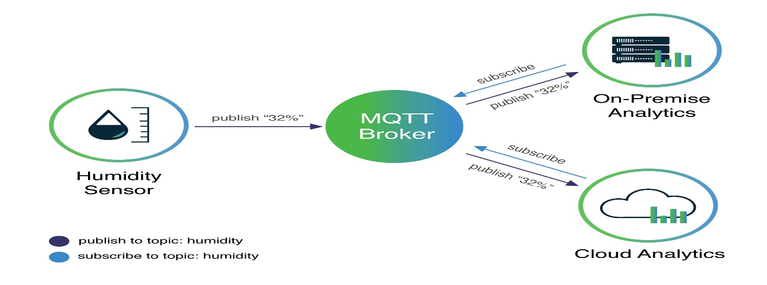

Features:

1. Quality of delivery – ensures proper delivery of messages.

Challenges:

1. Exploring different MQTT brokers.

Using different broker to get which broker is most reliable

1. Using both local, web, and docker.

Using all three types for testing and reduce dependence on local machine

Learnings:

1.Making Producer and consumer for proper transfer of messages.

2.Producers and consumer with various configurations.

KAFKA

What is KAFKA?

Apache Kafka is a distributed data store optimized for ingesting and processing streaming data in real-time. Streaming data is data that is continuously generated by thousands of data sources, which typically send the data records in simultaneously. A streaming platform needs to handle this constant influx of data and process the data sequentially and incrementally.

Use cases of KAFKA

1. Messaging 2. Website activity tracking

3. Commit log 4. Stream Processing

Necessary items:

Kafka Producer: A Producer which stream data according to the specified topic.

Kafka Consumers: A Consumer which can get data from specified topic.

Features:

1. Balancer - Send messages to kafka partitions. The balancer can be implemented with own logic or there are predefined balancers.
2. Consumer Group – This concept is present on the consumer side where a data will be processed by only one consumer in the consumer group.
3. Group Topic – This can help us to add multiple topics to a single consumer.

For more Features: [KAFKA_GO DOCUMENTATION](https://pkg.go.dev/github.com/segmentio/kafka-go#readme-reader)

KAFKA + MQTT.

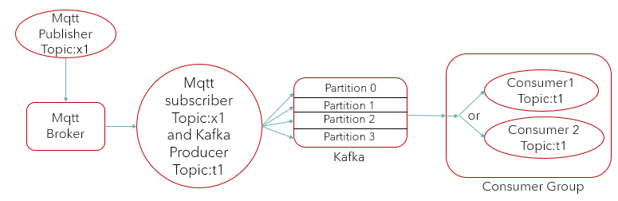

MQTT Producer will publish a message to a topic which will be read by a MQTT Subscriber via a MQTT broker. Then from MQTT Subscriber a KAFKA Producer will listen and write to a partition of the specified topic according to the balancing configuration in the KAFKA Cluster inside broker. From the partition KAFKA consumer will read and do further processing.

Challenges:

1. Separate dial of consumer for each topic.
2. The point where is Kafka get message from Mqtt is known as KAFKA_MQTT Connector. Here the present connector is written by us. But it is not reliable or test.

So, a tested connector is preferred.

Challenges for connector- 1. Works only on Linux or MacOS.

Started to install Linux and installed confluent but unable to connect to localhost for communication.